Shaping the Values of Youth: Sunday School Books in 19th century America

Introduction

One hallmark of the digital age is the power to place the most obscure information and literature at the fingertips of anyone online. At one time the reading public gained access to its past by entering libraries, visiting monuments, and lining their own shelves with the famous and esteemed works of literary achievement. The ephemera of the day, like the materials that comprise this collection, tracts cheaply printed and bound by authors who have barely escaped the oblivion of anonymity, could only be found in the odd corner of a used book store, archives, and special collections. But now, through the technologies of digitization and the Internet, virtually anyone can look at virtual materials that were once the province of dogged scholars and specialists. This searchable collection of long-forgotten nineteenth century books and tracts for young people is in many ways exemplary of this power. One can read the texts and see images of the actual volumes—bindings, pages, flyleaves, frontispieces, marginal scribbling, and inscriptions. This is all the more remarkable given that this archive of materials has been, as a whole, so little commented upon. The mass of juvenile literature is as forgotten as it was once pervasive and the religiously oriented literature that this collection presents, focussing on the period between 1820-1880, is some of the most forgotten. The well-known authors in this collection, Jacob Abbott, author of the Rollo stories, and Timothy Shay Arthur, whose Ten Nights in a Barroom was one of the great temperance bestsellers, achieved renown in their day but are little more than footnotes today. Little is known about many or most of the other authors, though we have provided as much biographical information on them as we could locate. But if what this collection presents is obscure that is because it is derived from the fabric of ordinary nineteenth century life.

Tom Sawyer and the Problems of Nineteenth Century Juvenile Literature

And it is not merely the fact that these books are little known that makes them obscure. The mode of moral instruction and the world in which they were valued is gone as well. From a strictly literary or aesthetic point of view, these books have little to recommend them. It is even fair to say that the modern American literary idiom was forged in opposition to this kind of writing. In The Adventures of Tom Sawyer, Mark Twain preserved his version of that world—of Sunday School, rote memorization, ticket reward systems (which Tom Sawyer famously games), Bible prizes, and the juvenile literature that were part and parcel of his childhood in the 1840s. He describes the instructional style of Mr. Walters, the Sunday-school teacher, whose “voice had acquired a peculiar intonation which was wholly absent on week-days.”

“Now, children, I want you all to sit up just as straight and pretty as you can and give me all your attention for a minute or two. There—that is it. That is the way good little boys and girls should do. I see one little girl who is looking out of the window—I am afraid she thinks I am out there somewhere—perhaps up in one of the trees making a speech to the little birds. [Applausive titter.] I want to tell you how good it makes me feel to see so many bright, clean little faces assembled in a place like this, learning to do right and be good.” And so forth and so on. It is not necessary to set down the rest of the oration. It was of a pattern which does not vary, and so it is familiar to us all.

For the modern reader trying to understand nineteenth century moral education in America, the key to the passage lies in Twain’s sense of the familiar that we have taken away from this era and this mode of instruction. Mr. Walter’s peculiar change in tone of voice suggests all we need to know: a new attitude was being brought to bear on children that had its own tone and psychology. A brief sample of the mixture of condescension and coaxing that marks the rhetoric of Sunday school is sufficient to conjure it up. With a twinkle of mirth, Twain can assume that this style was so immediately recognizable and unvarying to any of his readers in the 1870s that he need not even describe it. Et cetera, et cetera. Twain’s underlying point—one that has become a cliché of the twentieth century—was that Sunday school was based on an idealization of virtue at odds with the nature of children and perhaps human nature altogether, one that produced boredom, hypocrisy, and uncritical obedience. Tom Sawyer was calculated to provide a record of that idealization and to puncture it.
In doing so Tom Sawyer also provided a catalogue of the juvenile moral literature of this era. As Twain tells it, from time immemorial, on “Examination” day, girls would hold forth on tried (or tired) and true themes: Friendship; Memories of Other Days; Religion in History; Dream Land; The Advantages of Culture; Forms of Political Government Compared and Contrasted; Melancholy; Filial Love; Heart Longings. A canvassing of the books in this digitized Sunday School Book collection reveals the general sources of these themes. Aunt Fannie’s “Golden Apples and Pictures of Silver” sermonizes on Solomon’s phrase “a word fitly spoken is like apples of gold in pictures of silver,” is a ready-made example. John Todd’s The Young Man (1844) contains chapters on “Character, Its Value,” “Character, Its Foundation,” “Temptations of the Young Men,” “Self-Government and the Heart,” and “The Great End of Living.” Each chapter a trove of essays suitable for examination day recitation.
Twain’s description was accurate because he was not inventing so much as cribbing from contemporary sources. “The pretended ‘compositions’ quoted,” he added in a note of explanation, “… are taken without alteration from a volume entitled ‘Prose and Poetry, by a Western Lady’—but they are exactly and precisely after the schoolgirl pattern, and hence are much happier than any mere imitations could be.” In addition to the generic compositions mentioned above, staples of classroom declamation such as Felicia Hemans “Casabianca,” and Lord Byron’s “Sennacherib,” and more generic pieces entitled “A Vision,” “A Missouri Maiden's Farewell To Alabama,” and “Is this, then, Life?” were all part of the Sunday school repertoire.
And just what were these compositions like? Twain remarked,

A prevalent feature in these compositions was a nursed and petted melancholy; another was a wasteful and opulent gush of "fine language"; another was a tendency to lug in by the ears particularly prized words and phrases until they were worn entirely out; and a peculiarity that conspicuously marked and marred them was the inveterate and intolerable sermon that wagged its crippled tail at the end of each and every one of them. No matter what the subject might be, a brain-racking effort was made to squirm it into some aspect or other that the moral and religious mind could contemplate with edification. The glaring insincerity of these sermons was not sufficient to compass the
banishment of the fashion from the schools, and it is not sufficient to-day; it never will be sufficient while the world stands, perhaps. There is no school in all our land where the young ladies do not feel obliged to close their compositions with a sermon; and you will find that the sermon of the most frivolous and the least religious girl in the school is always the longest and the most relentlessly pious. But enough of this. Homely truth is unpalatable.

The literary offenses of schoolgirls are of a piece with the literature they are cribbed from, and that this literature with its “petted melancholy,” unearned pieties, and egotistical use of artificial diction fosters a culture of banal hypocrisy. In fact, this hypocrisy is so banal to Twain that his mere remarking on it requires his own censure. “Homely truth is unpalatable.” Sunday school literature was, for Twain’s sensibility, so commonplace that to comment on it was to risk becoming as commonplace.
In Twain’s version, Sunday school literature was also part of a neatly gendered universe of moral instruction, a bastion of female oratory and composition. Boys like Tom Sawyer read Walter Scott and James Fenimore Cooper and recited (or tried to recite) political speeches like Patrick Henry’s “Give Me Liberty or Give Me Death”. These stories of frontier adventure and Indian captivity fostered their own hypocrisies and their own idealizations, but they were part of a boy’s literature, a sexually segregated world of adventure and romance in the American West, a world of dime novels and Horatio Alger stories that would come to include Twain’s Tom Sawyer itself (which as it happens was not written for boys but for adults).
This then is the common impression of this literature. Because precious little of the mass of Sunday school literature has actually filtered down to us, when people think about it at all, the Tom Sawyer version of it prevails. Indeed a good deal of this literature has many of the stylistic and rhetorical features that Twain dismisses. Sunday school books were didactic and moralizing. But in accepting his version of Sunday school literature we reduce it to its satiric form, we lose sight of what was compelling about it in the first place, and the strangeness of it that marks it as part of a particular cultural moment. If we are to find the fabric and texture of the juvenile world that Twain and his readers had known all too well we would do well to go back to the Sunday school literature of the period between 1815-1880. And that is the basic purpose of this digitized collection: to give readers a direct experience of juvenile fiction of the early to middle decades of the nineteenth century.
It is much more varied and stranger than most readers would suppose. Gender divisions, while they certainly existed, are not as neatly drawn. In Tom Sawyer, Twain suggests that the themes that little girls wrote on were “the same that had been illuminated upon similar occasions by their mothers before them, their grandmothers, and doubtless all their ancestors in the female line clear back to the Crusades.” Unlike this clean matrilineal descent, many of the themes that Twain accords to girls can be found for boys as well. Advice literature for boys teems with essays on these same themes and many of the works in this collection attempt to reconcile codes of masculine behavior with Christian piety. For example, the Protestant Episcopal children’s magazine of the 1850s and 60s, The Standard-Bearer, offered this image (Fig.1) in its inaugural issue as an explanation of its title.

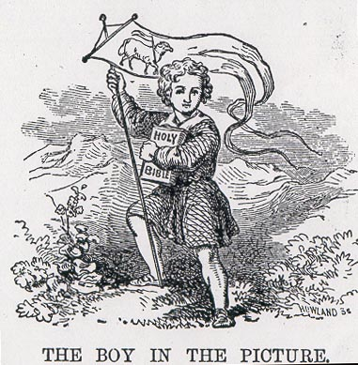
Figure 1. The Standard-Bearer July 1852

“My young friends,” the editor explained, “I wish you to understand that this boy, with his Bible and his banner, represents our little book; for we mean it to go, like a young standard-bearer or leader, wherever there are children who are willing to receive and to read it.” The magazine self-consciously figures its own evangelical mission as a boy’s enterprise. Like temperance crusades and the reform parades that were common in this era, the image of the boy with the bible and the banner attempts to fuse the practice of evangelical piety with the boy’s pride and love of parades and military display. This icon gives one small indication of the way this literature sought out boys and imagined the cultural work of the magazine as boy’s work. It suggests that the divisions between literature for boys and girls are less strict than might be commonly supposed, at least in terms of how authors may have imagined their audience.

Sunday School Books, the Rise of Print Culture, Democratization of Christianity, and Children’s Literature

But a corrective for commonly held assumptions about gender divisions is just one area in which this collection might prove useful. It is a record of a number of thematic divisions that preoccupied nineteenth-century America: sacred and secular, natural and divine, civilized and savage, rural and industrial, adult and child. It reveals a concerted effort to negotiate the tension between religion and culture, scripture and social reality, childhood and adulthood. It reveals the religious texture of everyday life for Christian antebellum America, the strenuous effort to forge a world founded on moral instruction—however banal or unrealistic or political. And so to aid the reader the collection is organized thematically. Books can be searched by category Advice (non-fiction); Animals and natural history; Child labor, orphans, poverty; Death, dying, and illness; Holidays; Immigrants; Moral Stories; Periodicals; Slavery, African Americans, Native Americans; Temperance, Tobacco; and Travel, Missionaries. These categories are intended to reflect the multiple ways in which Sunday school literature addressed itself to a host of social and cultural issues prominent in the Antebellum U.S. and of interest today
English Sunday school began as attempt to educate and evangelize the poor and parentless its American variants followed in this tradition. Consequently, one will find many a discussion of poor and the orphaned in this collection. One will find tales of factory life—tales of Lowell mill workers (The Factory Girl), and poverty (I Wish I Was Poor). One will find anti-slavery literature (the American Sunday School Union took an anti-slavery stance), and portraits African-Americans (Black Jacob), Native Americans (The Indian Chief and the Little White Boy), and Jews (Hadassah). One will find discussions of the roles of woman in society (The Young Woman’s Friend). All of these texts reveal commonplace and surprising notions of relations between Protestant white America and its religious and racial others. Figure 2, for example, could very well be Native American version of Little Eva with Uncle Tom. Indeed, the collection is intended to give a sampling of how the religious press addressed itself to the shifting issues of the democracy through juvenile literature.

Figure 2. The Indian Chief and the Little White Boy (1857)
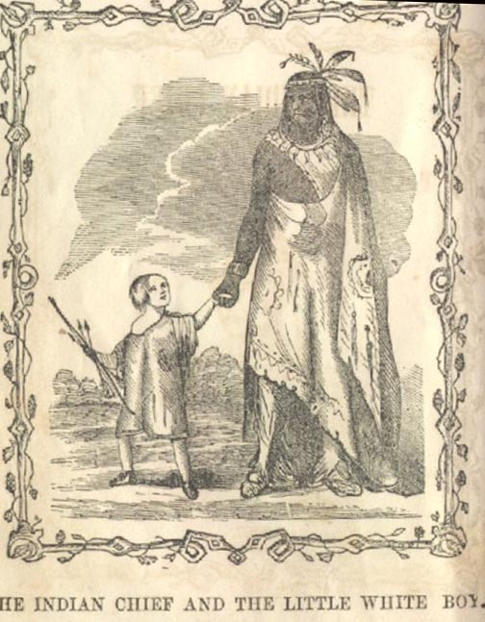

And it is also an example of the “democratization of American Christianity,” in Nathan Hatch’s phrase, or rather the way increasingly diverse religious groups took advantage of developments in print technology, multiplying the numbers of voices that could be heard throughout the country. The rise of Methodists, Baptists, and Mormons amid the other Protestant sects and the sense that these groups could have a say in the spiritual life of the nation, led to a great broadening or pluralizing of religious possibility. Like the Internet of the present, the rise of the printing press and the proliferation of Christian movements (especially those led by figures that did not come from elite or privileged backgrounds) promised a new kind egalitarian spirit in which any one may participate and have a voice. By the 1830s, Alexis de Toqueville, recognized the way American religious groups had aligned themselves with the principles of democratic culture, confidently asserting that, despite great sectarian variety (including American Catholics), “there is not a single religious doctrine in the United States hostile to democratic and republican institutions.” The American Sunday School Union used the Fourth of July celebration as a time to “show how closely the knowledge we propose to furnish in Sunday-school is allied to the preservation of liberty and intelligent exercise of the rights of an American citizen.” For some groups, there was a sense that unprecedented levels of religious and social harmony might be achieved and the free press was the medium of this movement. Between 1800-1880 the nation was flooded with streams of tracts, pamphlets, hymnbooks, devotional books, journals, magazines, and newspapers. By 1830, the American Tract Society (equipped with a steam-driven press) was producing over six million tracts per year. Similar figures were reported for the American Sunday-School Union. From that point through the Civil War, the tract societies were creating a form of mass literature of a religious character. This digitized collection generally reflects this development and follows that overall pattern (Table 1).

Table 1. Publications by decade and publisher in the Shaping the Values of Youth collection

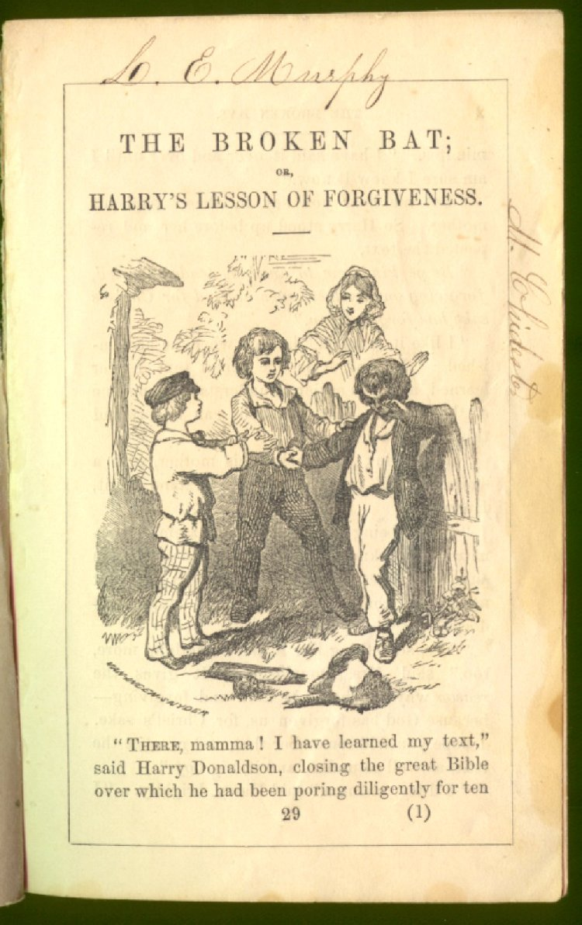
Sunday Schools began in England around 1780 providing basic education to working people (especially children of the poor) on their day off. By the first decade of the nineteenth century Sunday Schools and Sunday school societies were springing up in the United States. Sunday school libraries grew out of the way American religious culture entangled itself with American commerce and print culture. To bolster the lessons of the classroom, Sunday Schools created libraries that disseminated Sunday school books. As in Tom Sawyer, students were encouraged to read by rewarding memorization with tickets or premiums that could be turned in for a Bible or The Dairyman’s Daughter by Legh Richmond. Books and certificates (often very elaborate) were given as rewards. Below are two fine examples from the collection of a tiny text given to young readers (Figures 3 & 4).

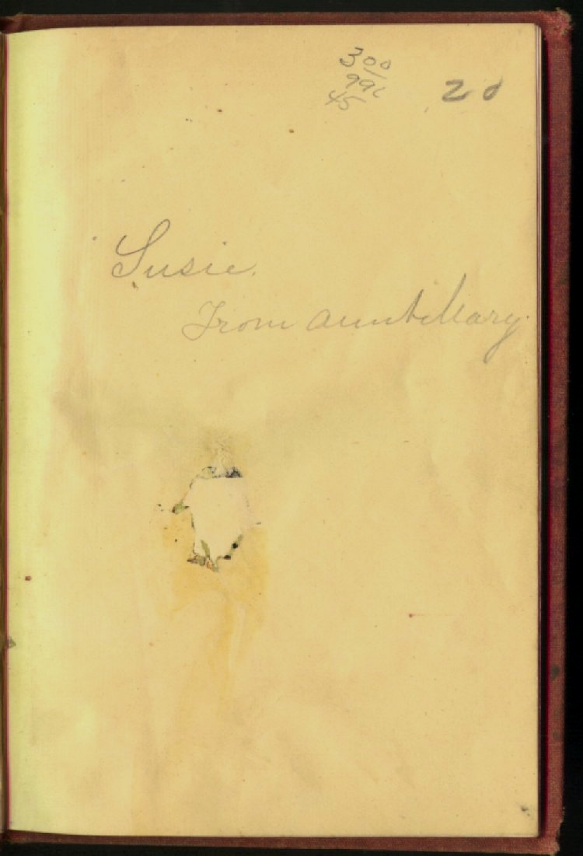
Figures 3&4. Small books like The Broken Bat or Harry’s Lesson in Forgiveness were given as rewards to children or inscribed to young readers by relatives (note the two signatures on the first page, one on the top margin and one on the right margin). Figure 4 with the inscription “Susie From Aunt Mary” is in our edition of Ethel's Gift: and Nellie's Miracle.

Libraries were an important in the spread of these books. According to the American Sunday School Union, 17% of affiliated schools reported having libraries in 1826; by 1832, 75% reported having libraries. Rural schools were less well-stocked than urban ones but the American Sunday School Union would sell these books in packaged Libraries of 100 for five or ten dollars (Figure 5). Sunday schools sprung up alongside weekday schools, sharing responsibilities for literacy. Sunday Schools amounted to a complex distribution network that brought children’s literature within most people’s reach. While promoting moral discipline, order, and respectability, Sunday schools and their libraries promoted literacy, spread this literature, attracted families to schools, and, in short, became the key to the rise of a popular religious culture that could be shared well beyond the walls of one church or the tents of the largest revival.
Figure 5. A Catalogue for the Sunday School Union (a number of these titles are in this collection)
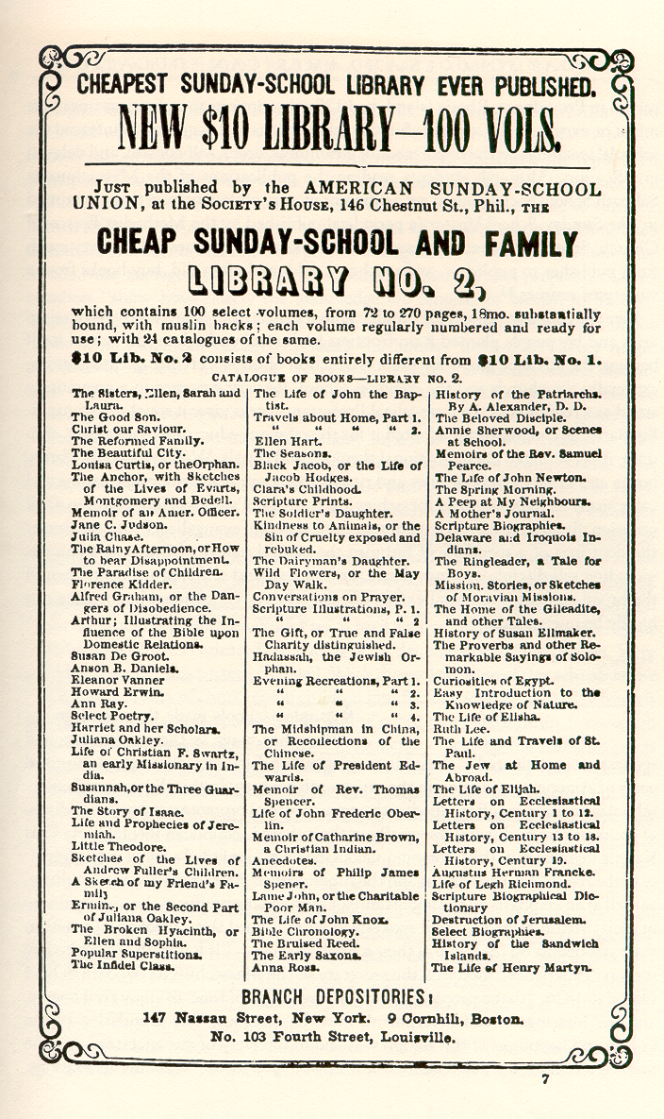

Really Young America in Literature
When most students encounter nineteenth century American Literary nationalism, the development of an American literature distinct from English literature, it comes through the manifestos of Emerson (The American Scholar, Self-Reliance) or the poems of Walt Whitman, Melville’s championing of Hawthorne, or perhaps in the writings of Mark Twain. One seldom considers the children’s literature of this era as part of the same movement, but books for children were a striking, if still infrequently discussed, branch of this development, for they would be the chief means of “instilling into the minds of our children and youth the principles of virtue and religion.” Blending the notions of republican and religious virtue, advocates of Sunday school literature frequently claimed that the blessings of American liberty were undergirded by the piety of its citizens. There were inevitable tensions in mixtures of religious and secular motives. This rhetoric would typically elide the more rebellious aspects of American life, asserting that love of republican government could be inculcated along with obedience and submission to God. In this digitized collection readers will come across many statements that mix democratic and evangelical aspirations. The introduction to The Young Man begins by outlining the potential peril of an America that is “troubled and haggard” despite being free in its thoughts, speech, and press and moves on to assert that “(America’s) destiny is to let a great nation come in contact with the God’s revealed word and to meet the responsibilities of the Gospel unshackled, and to be a mighty instrument of saving a world lying in sin” (34-35). Like John L. O’Sullivan’s 1845 editorial that first described “our manifest destiny to overspread the continent allotted by Providence,” religious advice books frequently expressed their various evangelical missions in terms of the United States democratic institutions and just as frequently mixed egalitarian and expansionist sentiments. Todd’s sentiment was common. As Carl Kaestle has explained, this ideological position emphasized the relative weakness of the republic compared to Protestant culture that moral virtue was the basis of civic virtue. Other works, such as Jonathan Cross’s The Pilgrim Boy interweave stories of moral development with legends of the Founding Fathers like Parson Weems’ fable of George Washington’s honesty.
Of course, like most groups seeking popular appeal, evangelical groups were quick to align themselves with the popular political freedoms of the United States but there was also a general sense that America needed its own literature and American children were not excluded from this need. In the United States in 1800, books specifically aimed at children were relatively rare. The Pilgrim’s Progress, Robinson Crusoe, neither of which were written for children, were two of the few books that nineteenth-century educators recalled from their youth. Webster’s spelling book, The New England Primer were common but they taught children to read. Hornbooks and fairy tales (Jack the Giant Killer, Puss in Boots, Cinderella) also existed, as did the odd chapbook. Isaac Watts’ Divine and Moral Songs were widely read, and, as the reader will see, in this collection reprinted with eye catching illustrations (evangelical children’s books pioneered the use of extensive illustration, see Figure 6).

Figure 6. Isaac Watts’ “How Doth the Little Busy Bee” illustrated from A New Picture-Book (New York: American Tract Society, 1830)
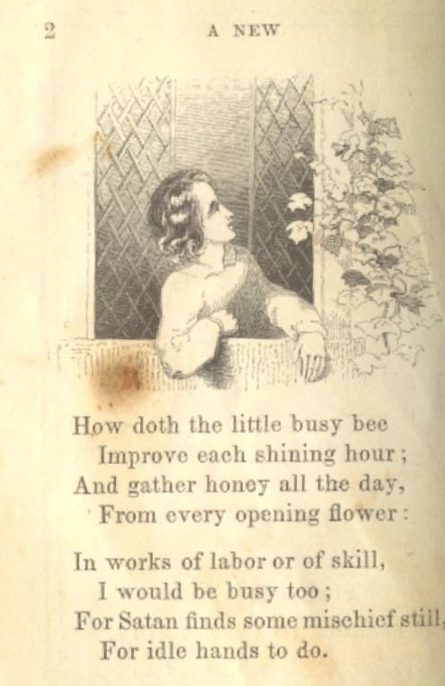
John Newbery, an 18th century English publisher of children’s books (for whom the Newbery medal is named), produced 300 or so titles for children (e.g. Goody Two Shoes, History of Giles Gingerbread), some of which were printed in the United States in pirated editions. But these titles were sporadically disseminated and it is unclear how widely available they were. There was certainly little systematic thought about the particular requirements of childhood as a category different from adulthood, let alone what might be suitable literature for children. There was also a sense that what children did come to read was imported from England.
Dr. Oliver Wendell Holmes, who was born in Boston in 1809, looked back on his childhood reading and remarked that,

It is a great misfortune…that we were bred to the constant use of words in English children’s books, which were without meaning for us and only mystified us. We were educated, you remember on Miss [Maria] Edgworth’s Frank and Parent’s Assistant; on Original Poems, and Evenings at Home [by Anna Letitia Barbault and Dr. John Aikin] and Cheap Repository Tracts, [by Hannah More]. Then we found ourselves in a strange world, where James was Jem, not Jim, as we always heard it; where a respectable but healthy young woman was spoken of as “a stout wench”; where boys played at taw, not marbles; where one found cowslips in the fields, while what we saw were buttercups; where naughty schoolboys got through a gap in the hedge, to steal Farmer Giles’ red-streaks, instead of shinning over the fence to hook old Daddy Jones’ baldwins; where Hodge used to go to the alehouse for his mug of beer, while we used to see old Joe steering for the grocery to get his glass of rum; . . . where there were larks and nightingales instead of yellow-birds and bob-o-links; where the robin was a little domestic bird that fed at the table instead of a great, fidgety, jerky, whooping thrush.
What a mess—there is no better word for it—what a mess was made of it in our young minds in the attempt to reconcile what we read with what we saw!

As Sunday Schools were an English institution imported to the United States much of the early Sunday school literature (or moral literature for children) that found its way to America was English in origin. Though we may not usually think of the United States as a “postcolonial” country, one might call Holmes’ reminiscence an instance of “postcolonial parallax” in which the cultural autonomy lagged behind the political. There was a sense that American children were getting their moral instruction secondhand and in a muddled fashion because the British idiom did not correspond to Holmes’ New England’s idiom and reality. While Holmes’ presentation of the differences makes the parallels one of easy translation, the confusion that these English books could present to a child posed a fundamental threat that was not lost on religious purveyors of children’s books. If they were confusing on a basic level to the American child then there was less chance of them holding any sway on moral, psychological, or religious grounds.
Holmes was longing for an Americanized children’s literature, akin to Noah Webster’s textbooks and American dictionary. So was the American Sunday School Union. Their 1831 report declared: “We have no need to go abroad for subjects and scenes of interest. American divines, statesmen and benefactors—American mountains, forests, prairies and rivers—American history, hopes and prospects—may surely furnish subjects enough of grateful, profitable and interesting contemplation to American children.” This was not true. As this digitized collection bears out, many of the text are in fact reprints of English stories. The Dairyman’s Daughter, a frequent book prize, was by Legh Richmond, the well-known secretary of the English Religious Tract Society. But the Sunday School Union was concerned and would frequently vet its reprints of English titles in an anonymous format, placing on the title page a statement that a work was “revised by the committee of publication” (this led to many texts being issued anonymously see Figure 7).

Figure 7. American Reprint Title Page
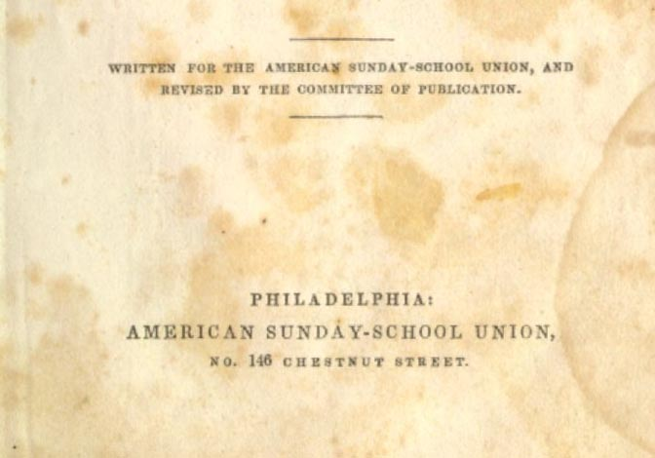
In other instances, the committee would add an introduction that would offer explanation that made analogies between English and American examples or pointed out the universal (hence, transatlantic) objective of the work, as in the introduction to Mary Bayly’s Ragged Homes and How to the Mend Them (1864).

“The scenes and localities of the present volume require little if any modification to make them exact counterparts of those with which our City Missionaries, our District Visitors, and our Mission (or Ragged) School teachers are familiar. St. Giles, the Five Points, Bedford or Baker Streets, are only names of different localities that possess the same general features. If the admirable tact and judgment, and especially the EMINENT EVANGELICAL SPIRIT, which characterize the measures detailed in these pages, shall furnish hints or motives to the like efforts in similar sections of our own cities, the purpose of republishing the volume will be answered.”

In a very real sense this disclaimer raises as many problems as it attempts to solve and reflects the partial Americanization of these books. The committee was committed to reprinting books that could be “Americanized: or adapted in ways appropriate to an American context and yet there were critical exceptions to the rule. In this case the poor were evidently classed as universal objects of pity. Therefore, the poor of London are the same as the poor of New York and London slums (St.Giles) are identical to New York slums (Five Points). The universalizing tendency of the evangelical mission also erodes the particularities of national difference. In other words, the committee decided to reprint Ragged Homes in spite of its obvious English context. This kind of gesture was indicative of the way nationalism was selectively invoked in Sunday school literature. There was commitment to it on general principles but subjects were excepted and explained away on universal moral grounds or because the group in question was not seen as part of what constituted American identity. The class of poor found in Ragged Homes would not be part of the common experience of the committee’s understanding of average Sunday School Union readers and so we find a class bias revealed in the introduction.
What the collection reveals is not so much the kind of original American language that one finds in Thoreau or Twain’s writing but the way evangelical children’s literature struggled to define itself as American in the face English influence and its own evangelical agenda. The moral stories are perhaps the best gauge of this and they function like family television programming, giving an American context and idiom to conventional moral situations and dilemmas. As time went on more American Sunday school stories were written and, if one moves through the collection chronologically, one will encounter a growing repertoire of moral stories that make explicit use of American situations. These run from such trivial examples as The Broken Bat which deals with malicious destruction of a small boy’s baseball bat to more extended treatments such as Kenny Carle’s Uniform, which deals with young Massachusetts boys playing soldier during the Civil War.

Sunday School Books, Moral Fiction, Child Psychology
All literary histories of the United States have remarked that the period between 1820 and 1860 was notable for the rise of fiction as popular form and novel reading as a popular pastime. This was the era in which authors began to sustain themselves by publishing and far and away the best selling works of the era were what has been commonly called sentimental novels. While it is well known that the canonical writers of the American Romantic tradition or American Renaissance (Emerson, Thoreau, Hawthorne, Melville, and Whitman) struggled with modest sales or outright professional failure, many other writers, especially around 1850 began to enjoy unprecedented success. Harriet Beecher Stowe’s Uncle Tom’s Cabin, Timothy Shay Arthur’s Ten Nights in a Bar Room, and Susan Warner’s The Wide, Wide World, being the three most prominent examples, all sold between 100,000 and 200,000 copies. These books, each bear a family resemblance to the works found in Sunday School books, each operates in an evangelical tradition, each portrays scenes of instruction and conversion. Stowe, Arthur, and Warner represent the masterworks of a genre in which Sunday School literature is the commonplace variant.
If this era saw a rise in the popularity of fiction, it also witnessed a growing complication between writing and piety. “The period,” as Lawrence Buell has observed, “saw a proliferation of literature using biblical themes and models that, however, took lace within the context of a softening of theological rigor.” The lists of titles in this collection or in the library catalogues sold by Sunday School Unions reveal that fictional tales comprise about one third of them but it was clearly the fastest growing and most frequently reprinted section of most publishers lists, especially after mid-century. Not surprisingly, fiction even when adhering to scriptural models was a controversial subject in Sunday school education. Controversy prevailed in regard to whether fiction was healthy for young children. Many religious authorities insisted that fiction should be excluded entirely, in that they tended to be sensational, prurient, or fantastic, corrupting the imaginations of the young or giving them a false sense of reality. This was by no means an opinion held exclusively by religious authorities. Thomas Jefferson, for example, inveighed against novel reading, claiming that it "it destroys its tone and revolts it against wholesome reading....Nothing can engage attention unless dressed in all the figments of fancy, and nothing so bedecked comes amiss. The result is a bloated imagination, sickly judgment, and disgust towards all the real business of life." The purveyors of evangelical children’s literature were conflicted over what constituted appropriate material and that in gaining a wider audience they may lose control of their doctrine and message.
As Anne Boylan has delineated it, “there was give-and-take between students and Sunday-school workers. Superintendents and teachers agreed on the inclusion of question books, catechisms, Bible concordances and dictionaries, Scripture biographies, and inspiring life stories, but they also recognized that children seldom checked out these books voluntarily.” It was clear to most observers that children returned time and again to the fictional works and would seldom take out the books “of more solid religious character.” Because teachers saw that it was most important to cultivate a taste for reading in their young students they began to rely more and more on “entertaining tales with moral messages.” The concern with fiction lay in the sense that not only could it lead to fantasy or sensationalism but also to kind of license with scripture itself, unorthodox or personal interpretations, and secular opinion. This was another reason that the Sunday school unions formed publication committees to oversee and regulate content.
By mid-century, Sunday school fiction was recognized as an increasingly important instrument in the process of “Christian nurture” (this phrase is from the title of Horace Bushnell’s influential 1847 manual for religious instruction, Views of Christian Nurture, published by the Massachusetts Sabbath School). Moral fiction was part of a plan to create a suitable moral climate for the rearing of children, obedience and instruction would take place by creating a moral climate or environment for nurture. This signaled changing attitudes toward the religious nature of children. Before the rise of this literature, it was commonly believed that children should be left to enjoy the freedoms of childhood and that children were largely incapable of genuine religious experience. Calvinist orthodoxy mandated the doctrines of original sin and infant depravity. By the 1850s, however, these attitudes started to shift. In the early decades of the republic the emphasis was on conversion experience and preparing children for an adult spiritual life, the new direction emphasized development, gradual growth, and process. Books would attempt ease children into the process of adulthood and adult religious life. The impressionability and emotional sensitivity of children were coming to be seen as reasons to train them early and romanticized notions of childhood spirituality were growing in popularity. Uncle Tom’s Cabin’s Little Eva is exemplar of the child who spiritualize the adult world and there was increasingly common sense that home was the center of religious life. As this collection reveals the attempts to shape the values of youth, it also reveals how the concept of youth was be reshaped by the culture at large. The advice manuals in this collection, in particular, reflect these shifts in attitudes toward children.
There are many lessons one might take away from this collection but perhaps it is the surprising examples, the ones that defy expectation, which we should look to as well as the general ones. The combination of fiction and scripture under the pressure of culture produces many unexpected results. Take for example, this scene from Kenny Carle’s Uniform.

Kenny does not mind the baby, nor yet what baby's eyes are saying, for Kenny has not finished his story; and we are just in time to hear the close.
"It's all true, mamma! just as true as any thing you ever heard of; we've got a general, and a captain, and a lieu ___, lu___. I can't remember the name, but Sam Clark's to be it, and Sam said I 'was too small;' but Joe and Cal said I
could fight,___ and bite, too, like a mosquito, ___ and you know how they bit us down at Newport, last summer; papa, too, and he's a big man; and I don't think we shall have any body to fight bigger than boys. Just see here, mamma, how I can bite, when I don't half try;" and Kenny seized baby's fat arm and tried his teeth on it. Looking up suddenly, Kenny exclaimed, with a triumphant air, "There! Look at that."
Baby began to cry.
"Don't, don't cry,___ be a brave soldier, baby, and then you shall have a uniform when you're big enough to walk. True, mamma, I didn't mean to hurt baby; I thought he'd know, and never make such a fuss; but he is a real goose, and I know Sam and Cal won't vote for him."
"Kenny," said Mrs. Carle, "roll up your sleeve and come to me."
"What for, mamma?"
"I wish to bite you. Now, you are not to cry,___ you are to think you are a soldier; come, give me your arm."
Kenny slowly rolled up his coat-sleeve, and bared his arm, his rosy lips quivering meanwhile, and his eyes glancing at his mother, to see if he could find out how hard she would bite; but Mrs. Carle was soothing baby and kissing his wounded arm. Kenny began to pull his sleeve down, his martial ardor somewhat lessened, and he thought of running; but Mrs. Carle had not forgotten, and when she had kissed the last tear away from baby's eyes, she took up Kenny's arm and bit it.
Kenny gave no sign. He shut his lips very tightly, and stood very still.
"Remember, the next time you hurt your brother, that you may suffer also," said Mrs. Carle. Then she laid baby down in his crib, and taking Kenny in her arms, she told him the story of the sermon preached eighteen hundred years ago on a mountain in Judea.
She told him of the multitude that were gathered to hear the blessed words, and that our Saviour taught, "As ye would that men should do to you, do ye even so to them."
"You mean, mamma, that if I was a baby and had an older brother, I should not like to have him bite me? Well, I know now that I should not."
"Yes, and I bit your arm that you might know how it hurt the baby to be bitten."
Kenny slid down and went to baby's crib, and whispered soft words of reconciliation, and I think he promised never to bite his little brother again.

Nineteenth century literature can often be stranger and more than one ever imagines. Is this an example of Christian nurture gone awry? In this story, set in the Civil War, of little Massachusetts boy who gives away his uniform to another boy whose father was killed in action so that he may have some warm clothes we are taken inside the didactic scene of discipline. What are we to make of it? One difficulty with this kind of fiction presents the modern reader lies in its distance from our own sense of proper parenting and moral instruction. Most readers would not find the invocation of the golden rule problematic but would object to the mother biting her child as a means of teaching it. Can we really equate “As ye would that men should do to you, do ye even so to them” with the lex talionis or law of equal and direct retribution “an eye for an eye, a tooth for a tooth,”? This is not exactly sparing the rod; this not exactly turning the other cheek. The psychological tension exhibited in the passage is also striking. The mother, of course, waits before she enacts her retribution to show that what she is doing is not fury or rashness. But if the mother is so self-possessed why does she not prevent the needless violence? In fact there is a double consciousness revealed in the passage. She hears what Kenny is saying about biting and military prowess and could easily anticipate what he was about to do. Kenny, for his part, we are told, is gauging how hard his mother’s bite will be and so obviously knows that biting hurts Why didn’t the mother stop the boy instead of taking us through a scene of self-righteous violence?
The passage is bizarre, funny, arch and an example of how fictional contexts can distort scriptural meaning, skewing it in very personal directions that we seldom associate with nineteenth-century moral instruction. I suppose it could be dismissed as an example of an attempt to wrench a scene into a scriptural context, an example of psychological coercion, but it is important to see that it can be those things and reveal the problems of maternal discipline, of rearing boys in families where the fathers are away. Mrs. Carle seems to require the calculated violence of her lesson to counter the military logic of Kenny’s soldier play. It also may suggest something of the necessary violence and bloodshed through which the Civil War grew to be understood at the time. One can only wonder at such passages. There are new histories yet to be written from works found in this collection. Despite Tom Sawyer, the world of nineteenth century children’s literature is not what we supposed and this collection is here to assist in the process of reexamining and rediscovering this world.

Mark Twain, The Adventures of Tom Sawyer (New York and London: Harper and Brothers, 1903): 51.
The Adventures of Tom Sawyer: 210.
The Adventures of Tom Sawyer: 205-6.
The Adventures of Tom Sawyer: 205.
The Standard-Bearer July (1) 1852: 1.
Alexis de Toqueville, Democracy in America, trans. George Lawrence (New York: Harper & Row Publishers Perennial Library, 1988): 289.
Anne M. Boylan, Sunday School: The Formation of an American Institution 1790-1880 (New Haven: Yale University Press, 1988): 53.
On print culture and popular religion see Nathan O. Hatch, The Democratization of American Christianity (New Haven and London: Yale University Press, 1989): 9-12, 141-46.
David Paul Nord, “The Evangelical Origins of Mass Media in America, 1815-1835” Journalism Monographs 88 (1984): 1-30.
Edwin Wilbur Rice, The Sunday-School Movement (1780-1917) and the American Sunday-School Union (1817-1917) 1917 (New York: Arno Press & the New York Times 1971): 146.
Boylan, Sunday School: 48-9.
Boylan, Sunday School: 53.
Carl Kaestle, Pillars of the Republic: Common Schools and American Society 1780-1860 (New York: Hill and Wang, 1983): 76-99.
Boylan, “Sunday Schools and Changing Evangelical Views of Children in the 1820s.” Church History 49 (1979): 321. Thomas Laquer, Religion and Respectability: The English Sunday School and the Formation of a Respectable Working Class (Yale: New Haven, 1977). Rice: 44-5.
American Sunday-School Union Annual Report, 1831: 20.
Mary Bayly, Ragged Homes and How to the Mend Them (Philadelphia: American Sunday School Union, 1864): 9-10.
Lawrence Buell, New England Literary Culture: From Revolution through Renaissance (Cambridge: Cambridge University Press, 1986): 166.
Quoted in Michael Davitt Bell, The Development of American Romance: The Sacrifice of Relation (Chicago: University of Chicago Press, 1980), p. 11.
Boylan, Sunday School: 50.

